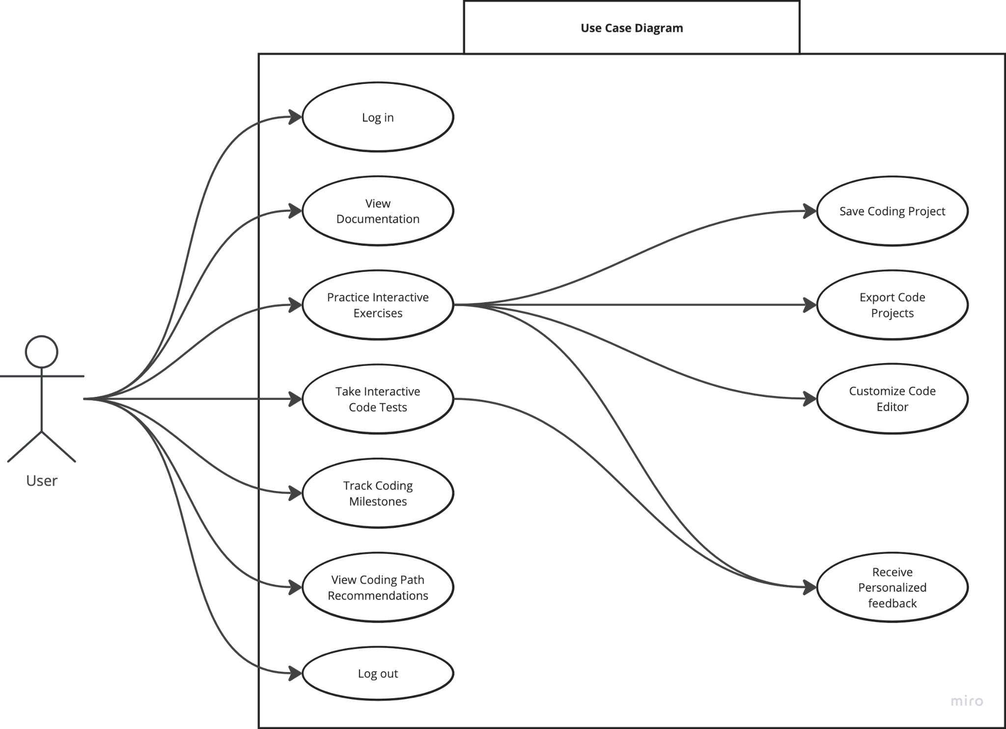

[Miro Board [View Only]](https://miro.com/welcomeonboard/MFhOcDJuZ1h5NVRrV1NqdHNEOFJ0NnRlZ1RjS1pLVlFYUE03NzZvdllTQnBWNlNpRnAwNmpYNTJ2N0hDNmlLMHwzNDU4NzY0NjAwNTYzNjY4MzAyfDI=?share_link_id=209200359808)

| Name/Title: | View Code Documentation |
| --- | --- |
| **ID:** | 11 |
| **Description**: | Allows users to access in-app documentation on different coding languages and concepts, offering explanations and code samples to help them understand syntax and functions. |
| **System Under Design:** | Documentation Access |
| **Primary Actor**: | User |
| **Participants**: | None |
| **Goal**: | To provide easy access to comprehensive coding references for users. |
| **Related Use Cases**: | Instance of: None  Included by: None  Inclusions: None  Extensions: None |
| **Invariant**: | Users should be logged into the application. |
| **Precondition**: | Users should be on IntuiCode and have access to the documentation library. |
| **Success Postcondition**: | Users can view and navigate through detailed documentation. |

| **USER STEPS**:  1. The user clicks on the "Documentation" tab.  2. The user searches for a specific topic or concept.  3. The user reads through the documentation.  … | **SYSTEM RESPONSE**:  2. The system loads available documentation  4. The system filters and displays the relevant section or topic.  6. The system tracks documentation history for quick access later.  … |
| --- | --- |

| Name/Title: | Save Coding Progress |
| --- | --- |
| **ID:** | 12 |
| **Description**: | The user can save their progress on exercises or projects, ensuring they can resume later from where they left off. |
| **System Under Design:** | Progress Management |
| **Primary Actor**: | User |
| **Participants**: | None |
| **Goal**: | Enable users to pause and continue coding exercises without losing progress. |
| **Related Use Cases**: | Instance of: None  Included by: None  Inclusions: None  Extensions: 6, Practice Interactive Exercises |
| **Invariant**: | Users should be logged into the application. |
| **Precondition**: | User is working on a coding exercise or project. |
| **Success Postcondition**: | The user's progress is saved, and they can resume later from the same point. |

| **USER STEPS**:  1. The user works on a coding exercise or project.  2. The user clicks the "Save Progress" button.  3.  … | **SYSTEM RESPONSE**:  2. The system regularly autosaves progress.  4. The system confirms that the current work has been saved.  … |
| --- | --- |

| Name/Title: | Customize Code Editor |
| --- | --- |
| **ID:** | 13 |
| **Description**: | Allows users to personalize the appearance and functionality of the code editor, including font size, and themes. |
| **System Under Design:** | Code Editor Customization |
| **Primary Actor**: | User |
| **Participants**: | None |
| **Goal**: | To provide users with a tailored coding environment suited to their preferences. |
| **Related Use Cases**: | Instance of: None Included by: None Inclusions: 10, Custom theme, layout Extensions: None |
| **Invariant**: | Users should be logged into the application. |
| **Precondition**: | Users are in the coding editor. |
| **Success Postcondition**: | The user's selected customization options are applied. |

| **USER STEPS**:  1. The user opens the settings in the code editor.  2. The user selects preferences such as font size, theme, or shortcuts.  … | **SYSTEM RESPONSE**:  2. The system displays available customization options.  4. The system updates the editor with the chosen settings.  … |
| --- | --- |

| Name/Title: | Take Interactive Code Tests |
| --- | --- |
| **ID:** | 14 |
| **Description**: | The user can take interactive tests where they write and submit code to solve specific problems, receiving immediate feedback. |
| **System Under Design:** | Interactive Code Testing |
| **Primary Actor**: | User |
| **Participants**: | None |
| **Goal**: | Test users’ knowledge through hands-on coding exercises with real-time feedback. |
| **Related Use Cases**: | Instance of: 6, Practice Interactive Exercises Included by: None Inclusions: 2, Receive Personalized feedback Extensions: None |
| **Invariant**: | Users should be logged into the application. |
| **Precondition**: | Users have access to the interactive code testing feature. |
| **Success Postcondition**: | The user submits code for evaluation and receives feedback. |

| **USER STEPS**:  1. The user selects a coding test.  2. The user writes code to solve the problem.  3. The user submits the solution.  … | **SYSTEM RESPONSE**:  2. The system displays the problem and coding environment.  4. The system evaluates the code and provides feedback.  … |
| --- | --- |

| Name/Title: | Track Coding Milestones |
| --- | --- |
| **ID:** | 15 |
| **Description**: | The system tracks users' progress toward specific coding milestones, such as completing a certain number of challenges or mastering a particular language. |
| **System Under Design:** | Progress Tracking |
| **Primary Actor**: | User |
| **Participants**: | None |
| **Goal**: | Help users measure their long-term progress toward coding mastery. |
| **Related Use Cases**: | Instance of: None  Included by: None  Inclusions: None  Extensions: 3, Progress Tracking |
| **Invariant**: | Users should be logged into the application. |
| **Precondition**: | Users should have completed several lessons or challenges. |
| **Success Postcondition**: | The user views their progress toward coding milestones. |

| **USER STEPS**:  1. The user navigates to their profile or progress page.  2. The user checks milestone progress.  … | **SYSTEM RESPONSE**:  2. The system displays progress toward milestones.  4. The system updates milestone tracking.  … |
| --- | --- |

| Name/Title: | View Coding Path Recommendations |
| --- | --- |
| **ID:** | 16 |
| **Description**: | The system recommends personalized coding learning paths based on the user's progress and performance. |
| **System Under Design:** | Learning Path Suggestions |
| **Primary Actor**: | User |
| **Participants**: | None |
| **Goal**: | Provide users with tailored suggestions to improve their learning experience. |
| **Related Use Cases**: | Instance of: None  Included by: None  Inclusions: None  Extensions: None |
| **Invariant**: | Users should be logged into the application. |
| **Precondition**: | Users must have completed lessons or quizzes. |
| **Success Postcondition**: | The user receives personalized learning path suggestions. |

| **USER STEPS**:  1. The user navigates to the "Recommendations" tab.  2. The user views suggested coding paths based on their learning history.  … | **SYSTEM RESPONSE**:  2. The system analyzes user progress.  4. The system displays personalized suggestions.  … |
| --- | --- |

| Name/Title: | Export Code Projects |
| --- | --- |
| **ID:** | 17 |
| **Description**: | The user can export their completed code projects as downloadable files or shareable links. |
| **System Under Design:** | Project Management |
| **Primary Actor**: | User |
| **Participants**: | None |
| **Goal**: | Allow users to save or share their completed projects externally. |
| **Related Use Cases**: | Instance of: None  Included by: None  Inclusions: None  Extensions: None |
| **Invariant**: | Users should be logged into the application. |
| **Precondition**: | Users must complete a coding project or exercise. |
| **Success Postcondition**: | The code is successfully exported as a file or link. |

| **USER STEPS**:  1. The user completes a project.  2. The user clicks on "Export" or "Share."  … | **SYSTEM RESPONSE**:  2. The system prepares the project for export.  4. The system provides a download or shareable link.  … |
| --- | --- |

<https://miro.com/welcomeonboard/Y3FZWEo5U0Z3b3A3WWtHdXFrdkVMMm9KeVVVeXBhWnNLZkJ1SE5YTEp3M0wzZndBYXM5Vjc4d0ZscmtyRW1TR3wzNDU4NzY0NjAwNTYzMjQ2ODM5fDI=?share_link_id=303010215316>

| Name/Title: | Join a course |
| --- | --- |
| **ID:** | REQ-29 |
| **Description**: | User |
| **System Under Design:** | The system name |
| **Primary Actor**: | User |
| **Participants**: | None |
| **Goal**: | Join a course to practice coding |
| **Related Use Cases**: | N/A Yet |
| **Invariant**: | User is On App |
| **Precondition**: | User is On the main Page. |
| **Success Postcondition**: | User joins course and is able to partake in course |

Use Case Diagram

| **USER STEPS**:  1. User Opens The app or website  3. User clicks Courses button  5. User searches for a course  7. User Joins course from list | **SYSTEM RESPONSE**:  2. User is greeted with Main screen Including a button that says courses(See mockups in SRS)  4.User is brought to a page that has all current courses, as well as a search bar in the corner to search for a course  e.g  For a user name…..  User name: [ ]  A password must require  Password: [ ]  6. Return list of courses that meet search criteria  8. User is returned to main courses list, with the course chosen added to the list. |
| --- | --- |

| Name/Title: | Taking quizzes |
| --- | --- |
| **ID:** | 1 |
| **Description**: | The user can access and take quizzes on the finished topics, upon completion the system will provide the user with personalized feedback. |
| **System Under Design:** | Tests and quizzes |
| **Primary Actor**: | User |
| **Participants**: | None |
| **Goal**: | To assess user understanding and provide learning feedback to help users improve |
| **Related Use Cases**: | Instance of: None  Included by: None  Inclusions:2, Personalized feedback Extensions: None |
| **Invariant**: | User should be logged into the application |
| **Precondition**: | The user must complete a topic before accessing the corresponding quiz. |
| **Success Postcondition**: | Users receive a score for their performance. |

| **USER STEPS**:  1. User navigates to the “Quizzes” section from the main menu.  3. User selects a quiz.  5. User completes the quiz and submits the answers.  … | **SYSTEM RESPONSE**:  2. The system displays a list of quizzes available to the user.  4. The system displays a list of questions to the user.  6.The system evaluates the answers and provides personalized feedback for the user.  … |
| --- | --- |

| Name/Title: | Personalized feedback |
| --- | --- |
| **ID:** | 2 |
| **Description**: | Allows users to receive personalized feedback based on the answer. |
| **System Under Design:** | Personalized feedback |
| **Primary Actor**: | User |
| **Participants**: | None |
| **Goal**: | Provide explanations to questions and answers to facilitate learning. |
| **Related Use Cases**: | Instance of: None  Included by: 1, Taking quizzes  Inclusions: None Extensions: None |
| **Invariant**: | User should be logged into the application |
| **Precondition**: | User submits a quiz. |
| **Success Postcondition**: | User receives personalized feedback |

| **USER STEPS**:  1. User submits the answers to the quiz  3.  5. | **SYSTEM RESPONSE**:  2. The system evaluates the received answer with the correct answer.  4. The system displays feedback to the user, indicating whether the answer was correct or incorrect.  6.The system updates the user's quiz progress and ends the quiz. |
| --- | --- |

| Name/Title: | Progress Tracking |
| --- | --- |
| **ID:** | 3 |
| **Description**: | As users follow a tutorial, the system displays a progress bar at the top of the screen to show how much of the tutorial has been completed and what remains. |
| **System Under Design:** | Progress Tracking |
| **Primary Actor**: | User |
| **Participants**: | None |
| **Goal**: | To motivate the user to complete the full course. |
| **Related Use Cases**: | Instance of: None  Included by: None  Inclusions: 4, Streak counter Extensions: None |
| **Invariant**: | User should be logged into the application |
| **Precondition**: | Users should be on the landing page when they’re logged in. |
| **Success Postcondition**: | The progress bar shows the current user’s progress. The user can continue from the point where they left. |

| **USER STEPS**:  1. The user completes a section of the tutorial and clicks "Next" to proceed to the following section.  3. The user continues working through the tutorial, periodically checking the progress bar to see how much of the tutorial is left.  5. | **SYSTEM RESPONSE**:  2. The system updates the progress bar to reflect the completion of the current section and the start of the new section.  4. The system automatically saves the user's progress as they complete each section.  6. |
| --- | --- |

| Name/Title: | Streak Counter |
| --- | --- |
| **ID:** | 4 |
| **Description**: | The system records the number of consecutive days the user engages with the platform, displaying a streak count to encourage consistent practice and learning. |
| **System Under Design:** | Practice Interactive Exercises |
| **Primary Actor**: | User |
| **Participants**: | None |
| **Goal**: | Encourage users to maintain consistency by tracking their engagement streak. |
| **Related Use Cases**: | Instance of: None  Included by: 3, Progress Tracking  Inclusions: None Extensions: None |
| **Invariant**: | User should be logged into the application |
| **Precondition**: | Users should be on the landing page when they’re logged in. |
| **Success Postcondition**: | The system updates the streak counter and displays the current streak information. |

| **USER STEPS**:  1. The user logs into the app.  3.  5. | **SYSTEM RESPONSE**:  2. The system compares the current date with the last recorded activity date.  4. If the user's last activity was the previous day, the system increments the streak counter by one.  6.If the user's last activity was more than one day ago, the system resets the streak counter to one. |
| --- | --- |

| Name/Title: | Reference book |
| --- | --- |
| **ID:** | 5 |
| **Description**: | Users can bookmark learning resources for future reference, organizing them into a list that can be accessed from the user interface. |
| **System Under Design:** | Practice Interactive Exercises |
| **Primary Actor**: | User |
| **Participants**: | None |
| **Goal**: | To enable user have quick access to their saved bookmarks |
| **Related Use Cases**: | Instance of: None  Included by: None  Inclusions: None Extensions: None |
| **Invariant**: | User should be logged into the application |
| **Precondition**: | Users should be on the landing page when they’re logged in. |
| **Success Postcondition**: | The resource is successfully added to the user's list of bookmarks. |

| **USER STEPS**:  1. The user views a list of available resources or opens a specific resource.  3. The user clicks on the "Bookmark" button to save the resource.  5. | **SYSTEM RESPONSE**:  2. The system displays the resource details, including a "Bookmark" button or icon.  4. The system adds the resource to the user's list of bookmarked items.  6. |
| --- | --- |

| Name/Title: | Practice Interactive Exercises |
| --- | --- |
| **ID:** | 6 |
| **Description**: | Allows users to engage in interactive exercises designed to improve their programming skills by presenting them with coding challenges and immediate feedback. |
| **System Under Design:** | Practice Interactive Exercises |
| **Primary Actor**: | User |
| **Participants**: | None |
| **Goal**: | Hands-on practice to receive real-time feedback that facilitates learning. |
| **Related Use Cases**: | Instance of: None  Included by: None  Inclusions: 2, Receive Personalized feedback Extensions: None |
| **Invariant**: | User should be logged into the application |
| **Precondition**: | Users should be on the landing page when they’re logged in. |
| **Success Postcondition**: | User receives personalized feedback  User’s progress is saved |

| **USER STEPS**:  1. User selects a topic to exercise  3. User reads the problem statement and writes code in the python editor interface  5. User reads the feedback, rewrites the code, and submits a new version. | **SYSTEM RESPONSE**:  2. The system displays the problem statement and the python compile environment  4. The system evaluates the submitted code, providing immediate feedback for the user  6.The system re-evaluates the submitted code and saves their progress. |
| --- | --- |

| Name/Title: | No distraction mode |
| --- | --- |
| **ID:** | 7 |
| **Description**: | Allows users to enable no distraction mode |
| **System Under Design:** | No distraction mode |
| **Primary Actor**: | User |
| **Participants**: | None |
| **Goal**: | Create a distraction-free environment. |
| **Related Use Cases**: | Instance of: None  Included by: None  Inclusions:None Extensions: Log in/Sign up |
| **Invariant**: | User should be logged into the application |
| **Precondition**: | Users should be on the landing page when they’re logged in. |
| **Success Postcondition**: | User enables no distraction mode |

| **USER STEPS**:  1. The user goes to the app's settings or preferences menu.  3. The user selects the "No Distraction Mode" option and toggles it on.  5. | **SYSTEM RESPONSE**:  2. The system presents options, including "No Distraction Mode."  4. The system activates "No Distraction Mode,"  the system suppresses pop-ups, alerts.  6. |
| --- | --- |

| Name/Title: | Offline learning |
| --- | --- |
| **ID:** | 8 |
| **Description**: | Allows users to learn without access to the Internet. |
| **System Under Design:** | Offline learning |
| **Primary Actor**: | User |
| **Participants**: | None |
| **Goal**: | Let users access the course materials without Internet connection. |
| **Related Use Cases**: | Instance of: None  Included by: None  Inclusions: None Extensions: None |
| **Invariant**: | Users should have an account in the app. |
| **Precondition**: | Users need an internet connection to download course materials initially. |
| **Success Postcondition**: | The lessons are downloaded and accessible. |

| **USER STEPS**:  1. The user navigates to the learning platform and selects the desired lessons, quizzes, and resources to download for offline access.  3. The user switches to offline mode on the learning platform, ensuring that all downloaded content is available for access without an internet connection.  5. | **SYSTEM RESPONSE**:  2. The system downloads the selected files..  4. The system switches to offline mode when the user selects this option, allowing access to downloaded materials without internet connection.  6. |
| --- | --- |

| Name/Title: | Choosing course topic |
| --- | --- |
| **ID:** | 9 |
| **Description**: | Allows users to browse and select course topics from a list of completed, in-progress, or unlocked topics. |
| **System Under Design:** | Choosing course topic |
| **Primary Actor**: | User |
| **Participants**: | None |
| **Goal**: | Enable users to navigate through available course topics, either for review or progression. |
| **Related Use Cases**: | Instance of: None  Included by: None  Inclusions: None Extensions: 5, Reference book |
| **Invariant**: | User should be logged into the application |
| **Precondition**: | Users should be on the landing page when they’re logged in. |
| **Success Postcondition**: | User gets the contents of the selected topic. |

| **USER STEPS**:  1. The user reviews the list of available course topics.  3. The user clicks on a specific course topic to view more details.  5. | **SYSTEM RESPONSE**:  2. The system lists all available course topics.  4. Upon user selection, the system fetches and displays detailed information about the chosen topic.  6. |
| --- | --- |

| Name/Title: | Custom theme, layout |
| --- | --- |
| **ID:** | 10 |
| **Description**: | Allows users to change the theme and layout of the application. |
| **System Under Design:** | Custom theme, layout |
| **Primary Actor**: | User |
| **Participants**: | None |
| **Goal**: | Enable users to customize the app’s appearance for a more personalized experience. |
| **Related Use Cases**: | Instance of: None  Included by: None  Inclusions: None Extensions: None |
| **Invariant**: | User should be logged into the application |
| **Precondition**: | Users should be on the landing page when they’re logged in. |
| **Success Postcondition**: | User’s selected theme is activated. |

| **USER STEPS**:  1. The user clicks on the “Theme and Layout” section in the settings from the main menu.  3. The user selects a preferred theme  5. | **SYSTEM RESPONSE**:  2. The system shows available themes and layout options.  4. The system refreshes the main interface to reflect the updated theme and layout based on the user’s selections.  6. |
| --- | --- |